**CN vs MCIc – X axis (sagittal plane)**



**Approach 1 - 2019_04_05_11_24**

**Network:**

Transfer learning from AlexNet changing last 3 layers.

|  |  |
| --- | --- |
| **Training parameters:**   * folds=3; * miniBatchSize = 30; * learningRate = 1e-5; * maxEpochs=30; * optimizer='sgdm'; * "L2Regularization", 0.0001 * "Momentum", 0.889 * 'Shuffle','every-epoch' | **Dataset:**   * nSlices=6; * gap=2; |

**Results:**

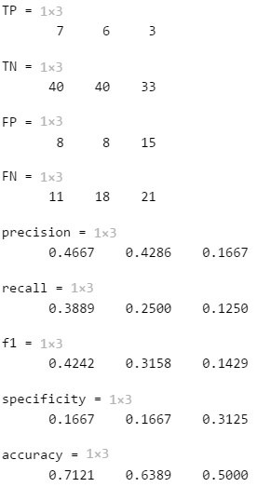

AverageAccuracy = 0.6170

**Approach 2 - 2019_04_05_14_39**

**Network:**

Transfer learning from AlexNet changing last 3 layers.

|  |  |
| --- | --- |
| **Training parameters:**   * folds=3; * miniBatchSize = 30; * learningRate = 1e-5; * maxEpochs=60; * optimizer='sgdm'; * "L2Regularization", 0.0001 * "Momentum", 0.889 * 'Shuffle','every-epoch' | **Dataset:**   * nSlices=6; * gap=2; |

**Results:**

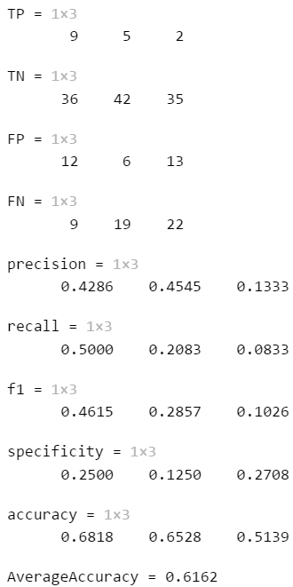

**Approach 3 - 2019_04_06_07_48 and 2019_04_27_11_23**

**Network:**

Transfer learning from AlexNet changing last 3 layers.

|  |  |
| --- | --- |
| **Training parameters:**   * folds=3; * miniBatchSize = 32; * learningRate = 1e-5; * maxEpochs=50 * optimizer='sgdm'; * "L2Regularization", 0.0001 * "Momentum", 0.9 * 'Shuffle','every-epoch' | **Dataset:**   * nSlices=6; * gap=2; |

**Results:**

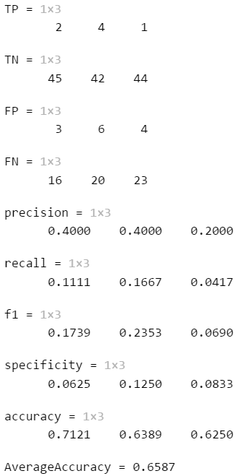

**Approach 4 - 2019_04_06_09_19**

**Network:**

Transfer learning from AlexNet changing last 3 layers.

|  |  |
| --- | --- |
| **Training parameters:**   * folds=3; * miniBatchSize = 32; * learningRate = 1e-5; * maxEpochs=200 * optimizer='sgdm'; * "L2Regularization", 0.0001 * 'Shuffle','every-epoch' | **Dataset:**   * nSlices=6; * gap=2; |

**Results:**

